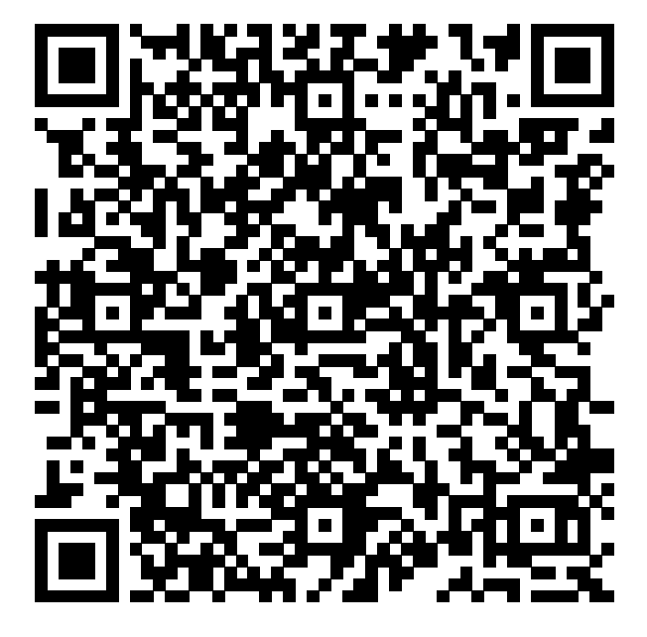
Vendor Application 2026
State Road Arts & Crafts Show
Sunday, November 15, 2026, 10 am-4pm

Scan for our Digital Application

Company Name:__________________________________________________________________________________
Primary Contact Name: ___________________________ Primary Contact Phone: ____________________________
Full Address (include Zip Code): ____________________________________________________________________
Email:___________________________________________________________________________________________
Fees: Early Bird by June 1, 2026: $100 ………. After June 1, 2026: $150
Electricity - Additional $20.00
Number of spaces:___________ Spaces are 10 ft wide x 8 ft deep each
Amount paid:____________ (Applications will not be juried without payment)
Method of Payment: Check ______ Venmo_______ (@SRE-CraftShow) Paypal ______ ( stateroadcraftshow@gmail.com)
Electricity needed (Y/N): ______________
Returning Vendors - Would you like to request the same space (Y/N): __________
Provide the booth space you are requesting: _____________

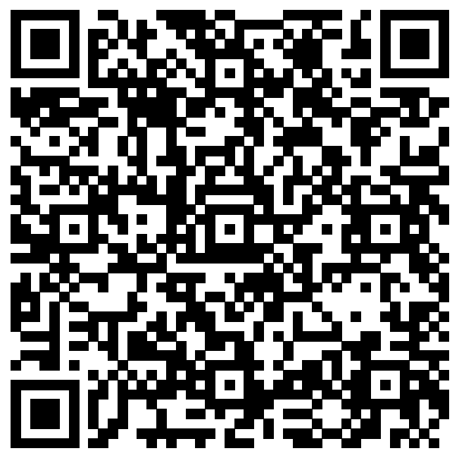
Please include 4 unmarked photos of your work with your completed application for the jury to review regardless of past show history.
1. One is required to be of you making your craft.
2. One photo should be of your display
3. Photos must show most of the items you will sell at the show.
Publicity posts on our social media (Facebook and Instagram) will be by request only
Please scan the QR Code
to fill out the publicity request form
All items must be handmade. All items must be appropriate for an elementary school audience and not contain profanity or reference drug use. Violation of this rule will be cause for immediate dismissal from the show with no refunds. All vendors must be juried yearly regardless of past history with the show. No refunds will be issued after the jury process unless your application is not approved.

Select the category that best describes your product(s):
___Holiday Home Decor ___Home Decor - Non-Seasonal ___Woodwork___Metal Work ___Jewelry ___Clothing ___ Quilting ___ Sewn ___Pottery ___Crochet/Knitting ___Personal Care Items ____ Pets ___ Food __ Outdoor___ Candles ___Accessories ___ Toys ___3D Printed ___Kitchen/Dining___ Art___Other
Please provide a detailed description of your product: ____________________________________________________________________________________________________________________________________________________________________________
______________________________________________________________________________________
Please describe, in detail, the methods used to create your art/craft for the jury:
____________________________________________________________________________________________________________________________________________________________________________
Visit our website: ​www.stateroadcraftshow.com​ and our Facebook page. Be sure to “like” us & “share” our event
SHOW INFORMATION
- Show Location: Fenton High School, 3200 W. Shiawassee, Fenton, MI 48430
- How to Submit Applications:
  - Email: Stateroadcraftshow@gmail.com
  - Mail: State Road Craft Show PO Box 265 Fenton MI 48430
  - Photos of your product and you hand making them must be included with the application
- Accepted Payment Methods
  - Check - Please make checks payable to State Road PTO
  - Venmo - @SRE-Craftshow
  - Paypal - www.stateroadcraftshow.com ​If you pay via Paypal, please use the same email address that is listed on your application or provide your full name and email used on the application
- Spaces are 10 ft wide x 8 ft deep
- If your application is not accepted, your payment will be refunded
- We will not promise or guarantee booth spaces or locations to anyone
- Special Display Requests: (i.e., electricity, location, etc.) ​We cannot guarantee to meet all of your requests. We strive to accommodate everyone to the best of our ability.
  - If you have special requests, we encourage you to turn your application in ASAP
- Booth spaces are first-come, first-served
- No refunds for cancellations after your application is juried **NEW** Jurying will take place at the time application is received
- You will be notified via email of the jury results
- Week of Show
  - Booth space assignments will be sent via email during the week of the show
- Day of Show
  - Vendors will be allowed in the building to set up at 7 am the day of the show. We do not offer the day before set up
  - All vendors must check in before setting up, and you must be checked in by 9 am. If you have not checked in by 9:15 am and have not notified us that you are running late, your spot will be forfeited with no refund of fees paid
  - Please bring your own help for loading in and out as our volunteers are limited. We do our best to provide assistance to those who are in need of it but it is not guaranteed.
  - You are allowed 2 people to work your booth. Additional workers are expected to pay our regular admission fee.
  - Food and beverages are not provided. However there will be on site food vendors.
  - We do not provide vendors with tables, chairs, table coverings, power cords, carts, dollies or change
  - The school is equipped with WiFi, but we strongly encourage you to be prepared to accept a form of payment other than credit cards
  - You must stay for the entire show. If you sell out of goods you may leave your booth unattended and return at 4pm to remove your booth. Do not begin to tear down early.
- If you are unable to attend, please let us know ASAP
- For inventory basing our show receives around 3,000 attendees yearly.
- You may not transfer or sell your space to anyone else for any reason
- Exhibitors are responsible for any loss or damage to their property or work
- All communication will be sent via email
- If you have any additional questions, please email our vendor team at stateroadcraftshow@gmail.com

